
Data Analytics for UK Air Quality
Student Name: Nazrana Patel ID:77288206


Table of Contents
1 Abstract - 4
2 Introduction 4
2.1 Background 5
2.2 Aim and Objectives 5
2.3 Rationale 5
2.4 Contribution 6
2.5 Organisation of report 6
3 Literature Review 6
4 Methodology – Findings and discussion 8
4.1 Data Collection method 8
4.1.1 Primary data: 8
4.1.2 Secondary Data: 8
4.1.3 Dataset interpretation 8
4.1.4 Dataset attributes information 9
5 Level 1: MODELING SVM MACHINE LEARNING Python Programing Presentation 10
5.1 Removing unwanted columns 11
5.1.1 Training & Testing ML (SVM) 11
5.2 Modelling SVM Model 12
5.2.1 Outcomes 12
5.2.2 Accuracy score 13
6 Level 2: Descriptive Statistics (Microsoft Excel) 13
6.1 Dataset information 13
6.2 Attribute selection for descriptive statistics 14
6.3 Dataset attribute 14
Descriptive statistics detail: 14
7 Level 3: Inferential statistics (Binomial THEOREM) 15
7.1 Attribute selection from dataset 15
7.2 Selection of trail from the dataset 15
7.3 Probability of dataset 15
7.4 Binomial theorem calculation in Excel 16
7.5 Binomial theorem chart 16
7.6 Finding & Description 17
8 Findings & Discussion 17
9 Recommendations – 21
9.1 . Conclusion and Future Work 21
10 Bibliography 23
Appendix 25
11 25
11.1 Machine Learning SVM model CODE Python 25
11.2 MODELING SVM MACHINE LEARNING SVM Python Programing Presentation 27
11.3 Removing unwanted columns 28
11.3.1 Training & Testing ML (SVM) 28
11.4 Modelling SVM Model 29
11.4.1 Outcomes 29
11.4.2 Accuracy score 30
12 Level 2: Descriptive Statistics (Microsoft Excel) 30
13 Level 3: Inferential statistics (Binomial THEOREM) 30
13.1 Attribute selection from dataset 31
13.2 Selection of trail from the dataset 31
13.3 Probability of dataset 31
13.4 Binomial theorem calculation in Excel 31
13.5 Binomial theorem chart 32

Abstract -
Data analytics and data visualization machine learning method has been suggested for prediction of air quality analysis, for the analysis of future forecasting the deep learning method has been developed. Primary data has been collected from Kaggle repository and secondary data has been collected from published research article. Methodology of this research based on machine learning and data mining approach to visualize and analyse the dataset of air quality. The development of smart cities IOT system enable the environmental protection agency to make attention to achieve the great outcomes of air pollution detection, IOT system connected in real time wireless network by using the internet 5G technology. By constructing machine learning algorithm which present the data analytics technique to estimate and validate the method of air quality determining and prediction.

Introduction
UK air quality data analytics using the machine learning algorithm has been, used widely to predict the air quality and level of oxygen and nitrogen level in atmosphere, to predict and analyse the various protocols of the field of data science and analysis. (Borrajo, L.Cao, R., 2020). For monitoring and analyzing the smart cities air quality and level of air resistance in particular areas in different regions of UK. The problem of big data analytics which has been measures & analyzed based on different pattern. The size of population size based on mean and different data analysis which has been measured and analyzed on various machine learning prediction and statistical method has been applied to visualize the features. The method of real data sets and concerned the level of population and level of pollution which used to analyze the urban air cities measuring the mean square error, which measure the level of pollution and level of air quality with nitrogen and oxygen level. The concerned view of data analytics to visualize the different dataset pattern and dataset systematic view in order to view the various cities air quality which was based on UK cities. The temperature is greater than 30 C might be possible in least locations of UK.

Background
(Rollo, F., Sudharsan, 2021) air quality sensor data acquisition to clean and monitor the air quality sensor data with the help of IOT system, smart cities and develop cities organized with IOT system that centrally connected with the internal internet technology of UK government to support the environment system. the primary development of air quality which used to monitor the importance of sustainable lifestyles with planned activity of corrective actions, the paper present the designed activity of end to end implementation of real world urban cities data collection which has been analyzed and predicted on machine learning and statistical method in order to achieve the data analytics framework. Various European project based in Italy and UK cities that uses to organize the smart cities with the help of smart machine learning and artificial intelligence based prediction method the low cost multi sensor IOT devices including LORA network setup with data collection of LORA server database, machine learning based anomaly detection method used to analyze the air cleaning, pollution detection, traffic crowd detection by using the sensor method.

Aim and Objectives
Aim to produce high quality data analysis and visualization and objective is to achieve the high score of machine learning analysis.

Rationale
(Kang, G.K.,and, Gao, J.Z., 2018) various researcher has been predicted and analyzed the air quality system the most essential activities has been achieved to get the answer of urban industrial solution, air quality prediction and evaluation method has become the essential the evaluation air quality has been predicted on different time scale pattern in winter and summer season to analyze the temperature scaling pattern the approach of big data analytics application using the machine learning method to monitor the air quality forecasting the resultant air quality evaluation using artificial intelligence method including decision tree, deep learning method to analyze and predict the big data analytics by using the python programming tool. (Liao, Z.,and Peng, Y., 2014) the evaluation of urban healthcare system was analyzed on machine learning method, including crowd source and cloud based air quality indicators to achieve the resultant of air level of urban & smart cities, the helping aid technology which was based on AI technology IOT system deeply involved with this system to admire the technology which support the big data analytics system in real time sensor

Contribution
The specialized and organized method monitor the work environmental including limited period of time, central effective decision making with data analytics with potential data analysis approach the research going to present the big data analytics in terms of monitor the air quality system with potential industrial workshops to analyst the big data problem in order, the effective decision making method with regional of shipping industry in Norway the performance of employees has been measured to analyze the risk factor of shipping company to manage the good and effective supply chain management. . Thus the air qualities in cities has been measure and analyzed through metrological sites, mobile data sources, crowdsourcing, including IOT sensor along with user body signals the artificial intelligence based smart urban cities measure the data quality data preparation has been achieved through the artificial intelligence method to support the healthcare department of internal cities zone.

Organisation of report
In this report machine learning support vector analysis has been made and descriptive statics analysed in excel sheet beside this binomial theorem inferential statistics has been made as well in excel sheet.

Literature Review
(Zhou, Z. 2017) with the growing development of industries based on, the development of UK industries zones to view and visualize the various roles and pattern of industrial application to view the various data items in certain condition, the collection of data analytics to measure the air quality analysis with detail and temporal analysis to explore the major areas of pollution to find out the decision making to find the efficient solutions. The author designed with visual data analysis, to visualize the data analytics system in order to monitor the station of various system to check and predict the 2D plot by uses the hirerechail clustering method with multidimensional multiscaling method of statistical analysis framework including voronoi diagram with storyline visualization with various attributes of data analytics scaling to explore the time scale data. (Ivanova¹, D. Elenkov, A., 2019). This paper explores the machine learning prediction method for IOT platform to investigate the Raspberry PI to analyze the various of pollutants in the air based on big data analytics the conceptual model of proposed system analyzed and predict the experimental framework which was designed for verification and validation system that achieve to predict and analyze the statistical modeling based analysis method to analyze the IOT system data in real time sensing devices which was connected on the physical locations of the regions that connected with the internet technology system. The dataset was provided to analyze and predict the executive environment agency which is ministry of environment and water in Bulgaria region. (Du, Y., Ma, C. 2017) the development of advanced multimodel scaling system in order to achieve the air quality and pollution quality monitory system of smart cities based in UK region, various smart cities connected with IOT based system to analyse and predict the system of motion that exists in the advance air system in UK. The air quality has been monitor and analyse with the help of machine learning modelling method and statistical scaling method, statistical regression model has been designed to view the future forecast of the existing dataset and also predict the different level of air in the region. The statistical explore the various integrated method such as map based view, calendar view and trend view to guide the analysis all of the mentioned visual method has been used to display the dataset location of interest and calendar of trends to view the discover linear periodical patterns, the system provides the various systematic tools that the data of size with different pattern of interest, the method of visual analytics that helps to assist the method of big data analytics in real world application such as air quality monitoring and mapping system. (Molka-Danielsen, J., Engelseth, 2017), indoor and outdoor air quality system has been measured and analyzed with machine learning method, to measure the air temperature level quality of air zone level, to measure the carbon dioxide system to comport the medical zones various medical health has been analyzed the perceived level of workers has been unhurried and examine reaction of heart rate detection the confined space method to measure the various air reactions and future forecasting has been measured with was based on blood pressure and headache attack.

Methodology – Findings and discussion
Methodology of this research proposed to design the visualize and analyse the data analytics of UK air quality system. (Liao, Z., Peng, Y., 2014), the proposed method of this research based on quantitative method, the quantitative method based on machine learning and statistical method, machine learning prediction model used to measure and quantify the air quality performance with reflection of air temperature on different region.

Data Collection method

Primary data:
The concerned of primary data has been collected from kaggle repository, which was essential online web portal to access view and analyse the big data analytics with respect of machine learning prediction method. The primary data attributes as follows:
Date, Ozone, status, nitric oxide, status, nitrogen oxide, status, nitrogen oxide with gas, sulphur, status.
The dataset based on excel csv file, the primary focus is to analyse the ozone level and nitrogen level in the air to quantify the air quality system.

Secondary Data:
The secondary data has been collected from peer reviews journal article, published research journals sites, IEEE Xplore, IEEE conferences, ACM library and Google Scholar.

Dataset interpretation
Dataset contain the UK air quality attributes which used to estimate the air quality level to determine the validate the air pollution level and clean air level by determining the machine learning based algorithm. Traffic increase day by day and by increasing the traffic the pollution has been increase and maximize the disease level. So machine learning smart analysis is able to highlight the air quality situation by determining the air situation. Now the IOT based system is able to detect the air quality which available on highways and national road to determine and predict the level of air and level of pollution within the air.

Dataset attributes information
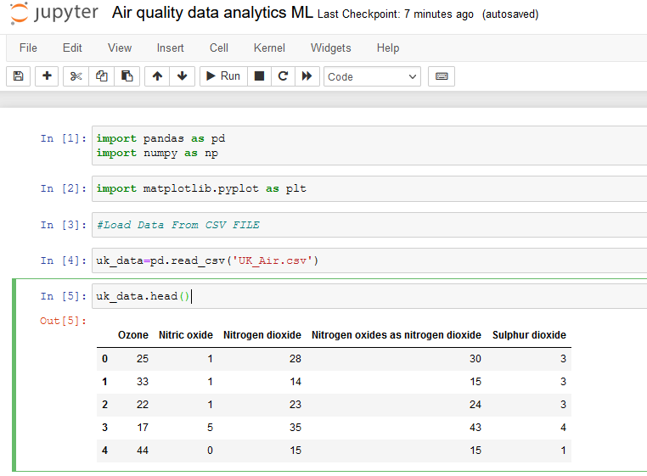

Level 1: MODELING SVM MACHINE LEARNING Python Programing Presentation

Removing unwanted columns
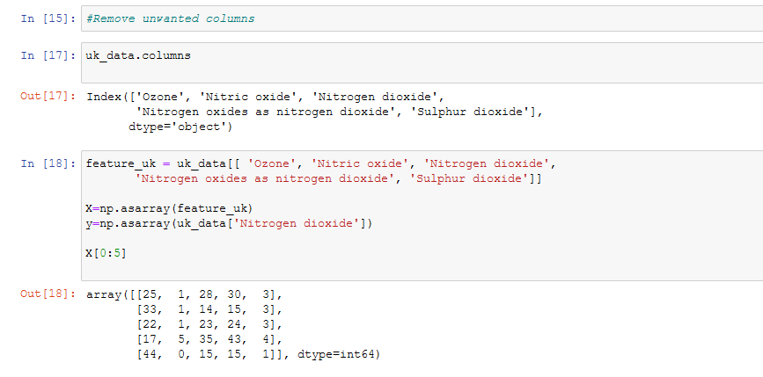

Training & Testing ML (SVM)

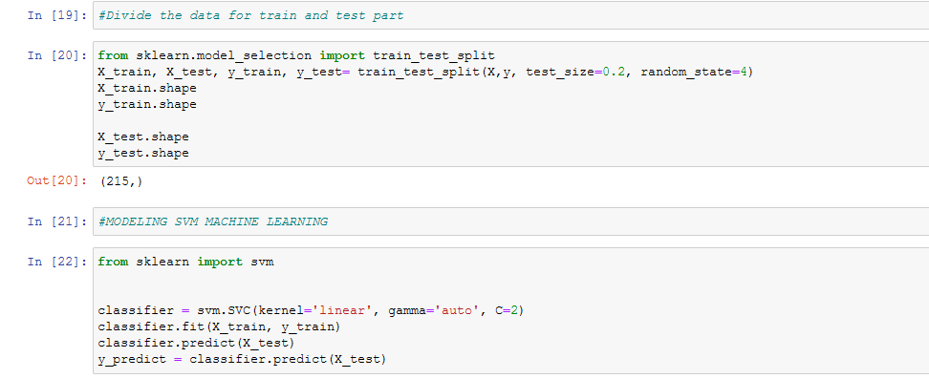

Modelling SVM Model
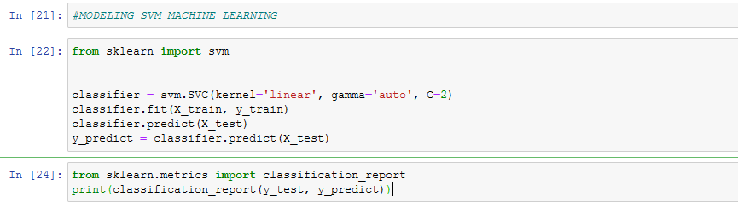

Outcomes
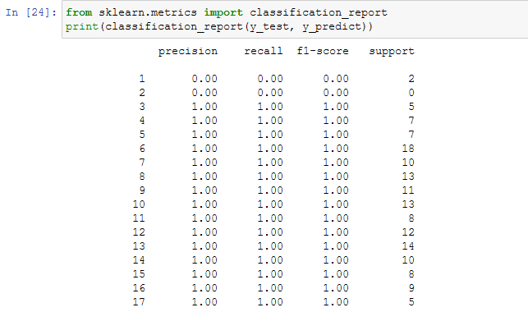

Accuracy score

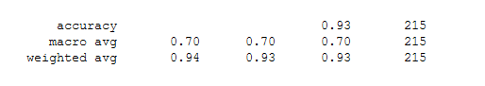

Level 2: Descriptive Statistics (Microsoft Excel)
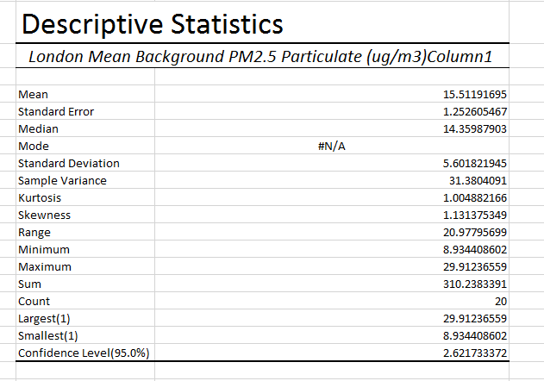

Dataset information
The dataset was shabby from London website. The dataset shows roadside and background average reading, the attribute contains, nitric oxide, nitrogen dioxide, oxides of nitrogen, ozone, the particular matter of dataset value PM10 to PM2.5 including sulphur oxide, the measuring with micrograms per cubic meter of air UG/m3 and the spreadsheet present the each row index level with readings falls in including chart showings with month and day.
Dataset contains London air quality average level on per month average level (Github 2020).

Attribute selection for descriptive statistics
This attribute taken from dataset csv file:

Dataset attribute
London Mean Background PM2.5 Particulate (ug/m3) Column1

This attribute selected from csv file dataset of London air quality per average month. Selection of 50 values.

Descriptive statistics detail:
- Mean : 15.51
- Standard error : 1.25
- Median : 14.35
- Mode: N/A
- Standard deviation : 5.30
- Sample variance : 13.38
Kurtosis | 1.004882166
Skewness | 1.131375349
Range | 20.97795699
Minimum | 8.934408602
Maximum | 29.91236559
Sum | 310.2383391
Count | 20
Largest(1) | 29.91236559
Smallest(1) | 8.934408602
Confidence Level (95.0%) | 2.621733372

Descriptive statistic used to describe the dataset in terms of statistics value. It’s usually used in research to present the dataset attribute values, it also used to validate and predict the future prediction based on the dataset value.

Level 3: Inferential statistics (Binomial THEOREM)
Binomial distribution using excel selecting the dataset attribute and select only 13 trails from the attribute value:

Attribute selection from dataset
Dataset attribute: London Mean Background Sulphur Dioxide (ug/m3)

Selection of trail from the dataset
X = 13

Probability of dataset
P = 0.06

Binomial theorem calculation in Excel
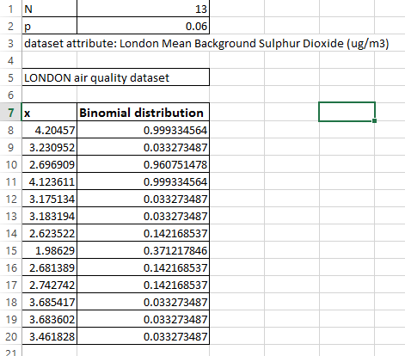

Binomial theorem chart
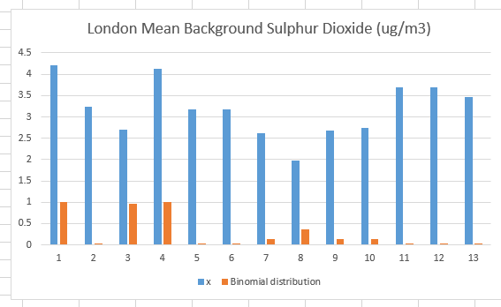

Finding & Description
(Braga, A., Martins, J.A. and Martins, L.D., 2018) negative binomial distribution regression best fit for the dataset, x present the number of dataset value and y present the number of binomial distribution trails. Since air pollution is one the major risk factors of human life, various internal disease has been happened due to air pollution, the increase of vehicle might be possible increase of air tight, the lung disease has been increase due to smoking and due to air pollution the factor analysis presented that the binomial distribution by selecting the one attribute from the dataset and taken the 13 trials which describe the negativity and positivity of the analysis. Various researchers has been analysed in the past and various researchers suggested that the air pollution presented through the regression poison model which describe the graph by selecting monthly average value from the dataset. The examination remained completed grounded on everyday statistics aimed at the retro among 2010 and 2014 concerning hospitalizations due to circulatory and breathing illnesses, stratified by age due to the concentration of air pollutants: CO, PM₁₀, NO₂, SO₂ and O₃ and meteorological variables. And negative binomial distribution present the old age of interquartile range.

Findings & Discussion
Visual analytics method has been proposed to measure the effective process of air quality dataset that become the hot research topic in these days. The processing of data analysis to analyse and quantify the big data analytics tools and technique which based on statistical modelling method, the proposed goal to achieve the outcomes of resultant attributes values has been achieve to organize the dataset. Data visualization method has been achieved with scatter plot, web based visual analytics, including spatial temporal with multi-dimensional features to monitor the air quality dataset. The GIS view used to view the spatial analysis of dataset in order the achieve the visual analysis the scatter plot interested way to analyse and predict them accordingly. The parallel plot of multi-dimensional method with inner tied newest approach which was able to configure the air quality analyst with different pattern of rules and regulations of statistical modelling. The standard unit colour mapping method with strategic view of air quality index. The standard interactive means helps to support the find out the standard error and mean squared error in the dataset. The air quality index dataset has been used to analyse and predict the spatial temporal statistics to analyse and predict the air quality pollution. (Daraio, E., Di Corso, E. 2018) machine learning supervised analytics method characterize the air quality measurement in order to achieve the air index that exists in the smart cities. The IOT enabled devices connected in real time environmental system to send the real time traffic positioning system that sustain to achieve the machine learning prediction method. Several cities has been made to analyze the smart cities air traffic including measurement of various air pollution system. the identification of casualties in the air quality system predicted decision making prediction system with the assistance of government officials that used to mitigate the air quality to support the development of smart cities in the urban region, different artificial intelligence based models has been previous developed by various research in order to quantify the method of sustainable development of air system. This research going to present the two machine learning method supervised learning method and unsupervised learning method including python PANDAS used to explored the various data analytics algorithm in the view of air quality system which based in the UK region. The occurrence of characterize method of machine which essentially used to provide the interface layer in which to proceeds the different modules of the data segment. The interesting insights of machine learning prediction method has been visually analyze and predict the quality related dataset. The similar concentration method to group the certain packages of deep learning to explored in more depth look to verify the and predict the ozone level and nitrogen level in the air which is essentially very helpful tools and method to quantify the statistical modelling method. The form of human readable method to optimize and characterize the various performance sheet and chart sheet method to calculate the correlation between the air pollution and metrological condition of the abstract level of segments in the air pollution the smart cities development has been finalized and quantify with the assistance of IOT devices that used to send the real time data to identify the traffic situation and identify the pollution quality in the air, the built in machine learning prediction method has been installed on this platform that used to help out and assist the various health department. Python PANDA has been used to validate and examine the real pollutant measurement to collect the major Italian cities dataset. The preliminary experimental results has been quantify and justified to solves the different situation to discover the similar group of air pollutant that interpret the correlation among the air pollution and whether data. (Kalamaras, I., Xygonakis, I., 2019) visual analytics to quantify the data analytics effectively used previously to explore and examine the air quality data to measure the AI based enhance IOT environment. The earlier development in the field of artificial intelligence and machine learning which essentially used to analyze the predict the performance of whether forecasting system. The method widely used to predict the air quality and pollution level with testing of ozone level and nitrogen level has been tested and examined with mean average value and mean squared error. The graphic visualization method obtain to present the outcomes of black boxing that undertake the method of end user level trust. The machine learning architecture present the visual analytics platform for making the custom level analytics of data to achieve the target result. The including and exclusion components has been used to predict the inclusion and exclusion method which ideally present the interactive visual analytics that linked with well define components for custom interactive analysis platform. The inclusion component used to predict and analyze the situational model of the air system in context of AI and machine learning predictions. (Marć, M., Tobiszewski, M., 2015) the machine learning summarizing tool effectively used to analyze the various statistical analysis such as mean value, median maximum value minimum value and quartile values. In the chain of air ozone layer level prediction ideally predict and analyze the air quality level of pollution which needs to develop the commonly air quality analytics and data frame. The segment of testing the level of air pollution and quantify the smart cities traffic which produces pollution from the vehicles, various electronic vehicle has been introduced in advance smart cities based in UK region. The cost of electronic vehicle comparatively low to measure and quantify the approach of data segment the operation of probability level testing which the aid of machine learning python prediction, monitoring level has been testing and verified the characterize method to obtain the automatic operation of summarize programs. The machine learning data summary present the state of the art report to ideally test and present the data analytic platform to test and quantify the approach which needs to address the problem. The drawback to taking low level and high level predictions commonly used in various areas, bio monitoring system cheap and convenient way to collect the traditional sample which becomes the more popular approach the monitoring system achieve to quantify the problem produces the air quality monitoring system, bio monitoring system cheap and confidential information system in which various problem has been analyze with biometric identification system of human being identification system in smart cities to produces the highest result, telemonitoring with sample of database system has becoming approach in more advance action. The drawback of standard monitoring system monitor the pollution level and highest quality prediction level of air system, the interesting opportunities to approach the air system. Machine learning and deep learning method deploy with highest frequqy rates in order to present the compact results of air pollution and sustainable air quality system, the coverage of large remote areas to constitute the complementary approach of traditional request cost. (Kök, İ., Şimşek, M.U. 2017) the deep learning model to predict the air quality of smart cities, the advance deep learning technology obtain with artificial intelligence algorithm which produces the highest accuracy of predictions and classification in order to obtain the air cleaning system this method also useful to assist and guide the ministry of health development that needs to regulate the sustainable environment in the near future. By using the information and communication technologies that interact with client computer sends the data in real time system with the help of IOT system. The IOT based smart cities application that support the various industrial applications, which needs to optimize the high priority and highest result. The government models used to predict and analysed the application of future prediction in order to executes the real time applications which highly required by the artificial intelligence group. Deep learning method has been used to obtain the highest accuracy for sustainable development of air quality system deep learning method highly recommended due to its highest level of integrity and availability. Deep learning method highly used for future prediction modelling. The novel deep learning approach has been used to analyse the big data analytics, several problems have been highlighted and solves to present the different smart cities situation. The development and growth of smart cities application IOT system enable the smart cities to detect predict and analyse the air quality and pollution level at the road. The machine learning approach previously used and examined by various researcher to obtain the highest result.

Recommendations –

(Mura, I., Franco, J.F 2020) the air quality testing and pollution quality has been tested with the help of machine learning models and deep learning modeling. The significant descriptive statistical analysis highly recommends by the WHO organization which support the environmental protection agency. The concentration of proposed WHO recommendation approach also suggest machine learning modeling to test and quantify the quantitative data analytics approach, various data visualization method has been used to plot the air quality data and analyze the future forecasting in order to deploy the system. (Huang, L., Zhu, Y., 2021) the numerical air quality data analytics modeling support the environmental protection agency which essentially used for analysis to control the air pollution, in the past the air pollution has been very serious issues now the issue has been resolved with the help of IOT system, IOT system support in the development of smart cities, and smart home applications and smart office equipment that used to restore the energy, cost and effort, various method of machine learning has been deployed such as Naïve bays testing and support vector machine modeling has been widely used in the past. The deep learning approach also used to test and quantify the future forecasting of the dataset the resultant values has been measured and analyzed with effective machine learning tools and method, the method of data visualization and data analytics method has been used to analyzed and predict the scatter plot, bar plot, and other box chart to present the various plot visualization technique. Data mining and statistical modeling approach present the state of the art report which needs of every organization and government agency to support and deploy the air pollution system to develop the sustainable smart city. Big data analytics, data mining approach has been effectively used to extract the exact information with based on knowledge discovery.

. Conclusion and Future Work
Air pollution has been significant and challenging issues that posing a threat on human being health. Air quality data is very rare and does not easily accessible by the European countries, to enable the air quality monitoring system with centralized hub monitoring system in the smart cities air pollution quality data has been collected on real time sensor based IOT system that connected through the wireless sensor networks, the centralized and combined system monitor and analyse the air pollution and test the ozone level and nitrogen level and the level of hydrogen and oxygen level which needs to test the human being health as well. However the data fusion algorithm has been used to measure the air quality information from various sources to provide the sustainable air monitoring system. So it is concluded that data mining approach used for big data analytics with the help of mining algorithm and big data analytics and visualization it is recommends that machine learning and deep learning approach with statistical method of quantitative used to deploy the machine learning architecture. The deep learning method used to predict the future forecasting of air quality dataset, for testing and examine the air pollution the classification approach of machine learning method has been used widely in the recent research. It is recommended and concluded that machine learning method has been used to analyse the big data analytics and prediction of air pollution system for the development and making of smart cities and smart industries.

Bibliography
Borrajo, L. and Cao, R., (2020). Big-but-biased data analytics for air quality. Electronics, 9(9), p.1551.
Zhou, Z., Ye, Z., Liu, Y., Liu, F., Tao, Y. and Su, W., (2017). Visual analytics for spatial clusters of air-quality data. IEEE computer graphics and applications, 37(5), pp.98-105.
Ivanova¹, D. and Elenkov, A., (2019). Big Data Analytics for Air Quality Monitoring Assessment Based on IoT Platform.
Du, Y., Ma, C., Wu, C., Xu, X., Guo, Y., Zhou, Y. and Li, J., (2017). A visual analytics approach for station-based air quality data. Sensors, 17(1), p.30.
Rollo, F., Sudharsan, B., Po, L. and Breslin, J.G., (2021), September. Air quality sensor network data acquisition, cleaning, visualization, and analytics: A real-world iot use case. In Adjunct Proceedings of the 2021 ACM International Joint Conference on Pervasive and Ubiquitous Computing and Proceedings of the (2021) ACM International Symposium on Wearable Computers (pp. 67-68).
Molka-Danielsen, J., Engelseth, P., Olešnaníková, V., Šarafín, P. and Žalman, R., (2017), September. Big data analytics for air quality monitoring at a logistics shipping base via autonomous wireless sensor network technologies. In (2017) 5th international conference on enterprise systems (ES) (pp. 38-45). IEEE.
Kang, G.K., Gao, J.Z., Chiao, S., Lu, S. and Xie, G., (2018). Air quality prediction: Big data and machine learning approaches. International Journal of Environmental Science and Development, 9(1), pp.8-16.
Liao, Z., Peng, Y., Li, Y., Liang, X. and Zhao, Y., (2014), June. A web-based visual analytics system for air quality monitoring data. In (2014) 22nd international conference on geoinformatics (pp. 1-6). IEEE.
Liao, Z., Peng, Y., Li, Y., Liang, X. and Zhao, Y.,(2014), June. A web-based visual analytics system for air quality monitoring data. In 2014 22nd international conference on geoinformatics (pp. 1-6). IEEE.
Daraio, E., Di Corso, E., Cerquitelli, T. and Chiusano, S., (2018), September. Characterizing Air-Quality Data Through Unsupervised Analytics Methods. In European Conference on Advances in Databases and Information Systems (pp. 205-217). Springer, Cham.
Kalamaras, I., Xygonakis, I., Glykos, K., Akselsen, S., Munch-Ellingsen, A., Nguyen, H.T., Lepperod, A.J., Bach, K., Votis, K. and Tzovaras, D., (2019), November. Visual analytics for exploring air quality data in an AI-enhanced IoT environment. In Proceedings of the 11th International Conference on Management of Digital EcoSystems (pp. 103-110).
Marć, M., Tobiszewski, M., Zabiegała, B., de la Guardia, M. and Namieśnik, J., (2015). Current air quality analytics and monitoring: A review. Analytica chimica acta, 853, pp.116-126.
Kök, İ., Şimşek, M.U. and Özdemir, S., (2017), December. A deep learning model for air quality prediction in smart cities. In (2017) IEEE International Conference on Big Data (Big Data) (pp. 1983-1990). IEEE.
Mura, I., Franco, J.F., Bernal, L., Melo, N., Díaz, J.J. and Akhavan-Tabatabaei, R., (2020). A decade of air quality in Bogotá: a descriptive analysis. Frontiers in Environmental Science, 8, p.65.
Huang, L., Zhu, Y., Zhai, H., Xue, S., Zhu, T., Shao, Y., Liu, Z., Emery, C., Yarwood, G., Wang, Y. and Fu, J., (2021). Recommendations on benchmarks for numerical air quality model applications in China–Part 1: PM 2.5 and chemical species. Atmospheric Chemistry and Physics, 21(4), pp.2725-2743.
Ardiles, L.G., Tadano, Y.S., Costa, S., Urbina, V., Capucim, M.N., da Silva, I., Braga, A., Martins, J.A. and Martins, L.D., (2018). Negative Binomial regression model for analysis of the relationship between hospitalization and air pollution. Atmospheric Pollution Research, 9(2), pp.333-341.

Appendix

Machine Learning SVM model CODE Python
import pandas as pd
import numpy as np
import matplotlib.pyplot as plt
#Load Data From CSV FILE
uk_data=pd.read_csv('UK_Air.csv')
uk_data.head()
uk_data.tail()

uk_data.shape
uk_data.size
uk_data.count()
uk_data['Ozone'].value_counts()
#Distribution of the classes

air_ozone = uk_data[uk_data['Ozone']==2][0:200]
nitrogen_level = uk_data[uk_data['Sulphur dioxide']==4][0:200]

axes = air_ozone.plot(kind='scatter', x='Ozone', y='Sulphur dioxide', color='blue',label='Ozone Level')
axes = air_ozone.plot(kind='scatter', x='Sulphur dioxide', y='Nitrogen oxides as nitrogen dioxide', color='red',label='Ozone Level',ax=axes)

#identifying unwanted rows
uk_data.dtypes
#Remove unwanted columns
uk_data.columns
Index(['Ozone', 'Nitric oxide', 'Nitrogen dioxide',
'Nitrogen oxides as nitrogen dioxide', 'Sulphur dioxide'],
dtype='object')

feature_uk = uk_data[[ 'Ozone', 'Nitric oxide', 'Nitrogen dioxide',
'Nitrogen oxides as nitrogen dioxide', 'Sulphur dioxide']]

X=np.asarray(feature_uk)
y=np.asarray(uk_data['Nitrogen dioxide'])

X[0:5]
#Divide the data for train and test part

from sklearn.model_selection import train_test_split
X_train, X_test, y_train, y_test= train_test_split(X,y, test_size=0.2, random_state=4)
X_train.shape
y_train.shape

X_test.shape
y_test.shape

#MODELING SVM MACHINE LEARNING

from sklearn import svm

classifier = svm.SVC(kernel='linear', gamma='auto', C=2)
classifier.fit(X_train, y_train)
classifier.predict(X_test)
y_predict = classifier.predict(X_test)

from sklearn.metrics import classification_report
print(classification_report(y_test, y_predict))

MODELING SVM MACHINE LEARNING SVM Python Programing Presentation

Removing unwanted columns

Training & Testing ML (SVM)

Modelling SVM Model

Outcomes

Accuracy score

Level 2: Descriptive Statistics (Microsoft Excel)

Level 3: Inferential statistics (Binomial THEOREM)
Binomial distribution using excel selecting the dataset attribute and select only 13 trails from the attribute value:

Attribute selection from dataset
Dataset attribute: London Mean Background Sulphur Dioxide (ug/m3)

Selection of trail from the dataset
X = 13

Probability of dataset
P = 0.06

Binomial theorem calculation in Excel

Binomial theorem chart

